Lone Star Event Center

Safety Guide
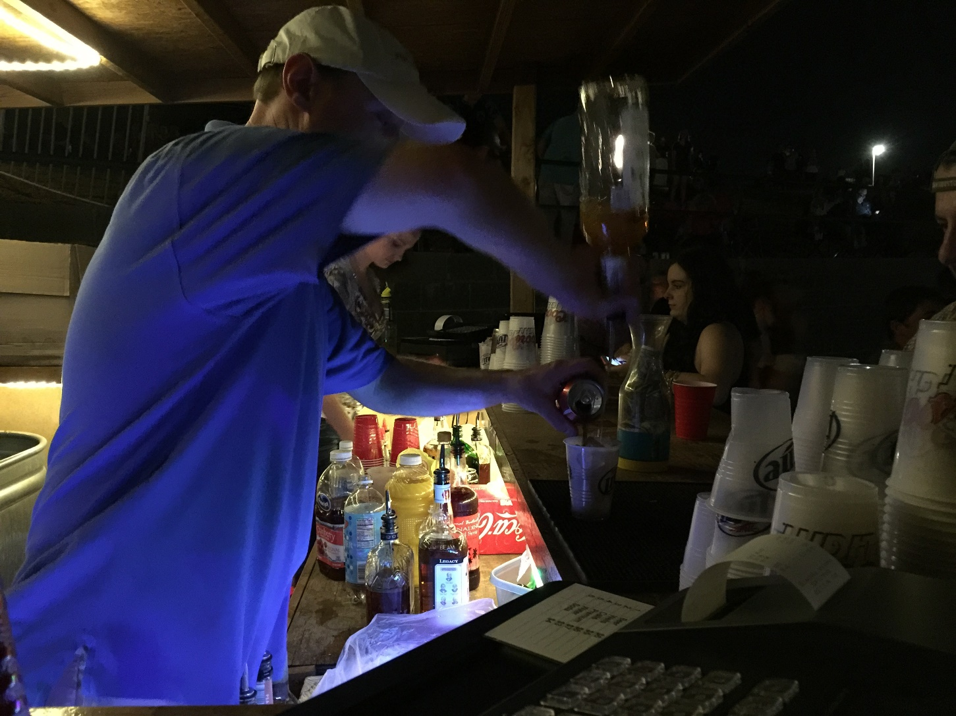

Contents
1. Introduction 2
1.1 About this Guide 2
2.Safety Commitment……………………………………………………………………………3
2.1 Event Facilities Commitment…………………………………………………………..3
2.2 Your Commitment……………………………………………………………………….3
3. Legislation, Policy and Procedures 4
  - Legislation 4
  - Event Facilities Safety Policy 4
  - Safe Work Methods 4
  - General On Site Safety 5
  - Housekeeping and Waste 5
  - Risk Management 5
  - Emergency Procedures 6
  - First Aid Procedures 6
  - Smoke Free Policy 6
  - Alcohol & Drugs 7
3.11 Onsite Traffic Safety and Parking…………………………………………………………………….7
3.12 Damage to Venue Equipment or Property…………………………………………………………..7
- Hazard Management 8
  - Restricted Areas 8
  - Manual Handling 8
  - Working with Electricity 9
  - Electrical Isolation 9
  - Residual Current devices (RCD) 9
  - Electrical Testing and Tagging 9
  - Hazardous Substances 9
  - Plant and Equipment 9
  - Working at Heights 10
  - Personal Protective Equipment (PPE) 10
4.11 Slips, Trips and Falls ......................................................................................................................................... 1o
  - Crowd Control 11
  - Additional Hazards 11

Introduction

About this Guide

Welcome to the Lone Star Event Center Safety Guide.

This guide has been prepared to provide all hirers, contractors, subcontractors, entertainers and any other person undertaking work on behalf of the hirer, relevant safety information whilst working on site at the Lone Star Event Center.

This information will assist all persons working at our venue and is a necessary step in the safety process.

Creating and delivering a safe environment can only be achieved by having a comprehensive safety management system in place, and one that can be clearly understood by all persons working on site.

Safety Commitment

2.1 Event Facilities Commitment

Event Facilities is committed to providing a safe environment for all employees, hirers, guests, visitors and contractors. To achieve this LSEC will take every practicable step to prevent accidents and injuries by identifying, eliminating or controlling potential hazards. LSEC will use sound risk management practices to ensure that our safety programs function effectively.

As managers of a significant high profile venue, we strive at all times to ensure that safety and a safe workplace is provided for all our staff and visitors.

The LSEC Safety Policy forms the backbone of our intent and clearly outlines our commitment to safety. A copy of the LSEC Safety Policy is available upon request. This safety policy and all associated procedures must be adhered to at all times, not just by our employees but anyone who enters or works at any of our venues.

LSEC recognize its "Duty of Care" responsibility to all parties and is committed to delivering the highest possible standards of safety and service.

The success of our health & safety program ultimately rests on the commitment of everyone to
Co-operate and work collectively with a "team spirit". To ensure that our goal is achieved all parties must understand their responsibilities and obligations.

Your Commitment
Along with LSEC you have a responsibility (duty of care) to ensure your health, safety and welfare whilst working at our venue. In fulfilling that "duty of care" both you and LSEC should pursue a vigilant, systematic approach to reducing the risk of injury by maintaining a safe environment.

Anyone engaged by the hirer to perform or work at LSEC venue are required to comply with The State of Texas health & safety policies, procedures, programs and other initiatives and to observe directions on health & safety from designated LSEC representatives.

All contractors performing work at LSEC venue are responsible for their own health & safety and that of others onsite and must report any incidents, accidents, injuries or hazards in the work place to an LSEC staff member as well as their employer. Contractors will ensure that no task will be undertaken if health and safety standards may be compromised.

Our staff will inspect and audit contractors to ensure they are complying with safety policies, procedures and safe work methods. LSEC requires all hirers, contractors, subcontractors and employees to fulfil their duty of care responsibilities by:

    - Providing a safe place of work
    - Providing safe systems of work
    - Providing safe plant and equipment
Providing training and supervision to all employees including casual labor under their direct control
    - Encouraging safe practices in the workplace

Legislation, Policy and Procedures

Legislation

In Texas there is health & safety legislation (OSHA) that applies to all workplace practices. All work carried out at LSEC venues must comply with this legislation and any person working outside of these requirements may be subject to legal action.

LSEC require all hirers/contractors involved in carrying out work at any of its venues to:

    - Have policies and procedures that aim to protect the health and safety of all
Ensure policies and procedures are documented and available to all employees, volunteers
- Ensure policies and procedures are implemented
- Undertake risk assessments to identify hazards and implement appropriate control measures in consultation with Event Facilities venue management

LSEC Safety Policy

In accordance with the OSHA Safety Policy, it is a requirement of LSEC that all Hirers/Contractors:

    - Practice safe work methods at all times to prevent injuries to themselves or others
    - Use appropriate Personal Protection Equipment (PPE)
Report all accidents, incidents and discomfort in an accurate and timely manner
    - Actively participate to identify and record hazards, and to ensure controls for all hazards are effectively implemented
    - Undertake appropriate training to ensure that they understand Health & Safety requirements and can perform all tasks safely
Read the OSHA Safety Policy In addition the Event Manager will:
    - Assist with the overall objective of continually improving Health & Safety via processes for consultation and participation.
Report any health and safety concerns immediately to the Hirer/Contractor.

Safe Work Methods

Safe work methods are only effective when each work process is properly planned and the staff are trained in the safety measures required for each job to be carried out. It is the responsibility of all hirer's and contractors to ensure that where there is a possible risk of injury and or death that they conduct themselves and their staff according to safe work methods.

General On-Site Safety

In order to have a safe workplace it is vital that everyone who performs any work in any LSEC venue has not only read and understood this Venue Safety Guide but is also familiar with the following rules:

    - Always conduct yourself safely
    - Never endanger anyone else with what you do
    - Always wear sturdy footwear
    - Wear suitable clothing
    - Never work whilst affected by drugs or alcohol
    - Obey the no smoking signs
    - Obey instructions from your supervisor or employer
    - Always wear Personal Protective Equipment provided by your employer
    - Always report hazards to your supervisor and LSEC staff
    - Under no circumstances should Fire and Building Protection Systems be turned off or any part isolated without prior approval by venue management.

Housekeeping and Waste

All contractors are responsible for keeping the work areas clean, tidy, free and clear of hazards at all times, this is of upmost importance in public access areas, thoroughfares and fire exits must be kept clear at all times. All rubbish and debris must be removed prior to leaving the site. No waste chemicals, cement or sediment should be disposed of by tipping down storm water drains.

Risk Management

All hirers and/or contractors must identify any foreseeable hazards, assess the risk and take action to eliminate or control that risk. Risk management is a regulatory requirement. The risk assessment process is a problem solving process that when taken step by step will lead to informed decisions about how best to avoid or control the impact of the risks identified.

There are 4 basic steps:

Step 1.
Step 2.
Step 3.

Step 4.
Identify the problem (hazard identification)
Determine how serious a problem it is (assess the risks)
Decide on what actions are to be taken to solve the problem (eliminate or control the risks)
Review the process and control measures to ensure that the risks are adequately addressed

An Event Risk Assessment (hazard identification) must be undertaken which considers every aspect of the work to be carried out. To help make this process easier we have a standard risk assessment template available and will provide guidance on how it should be filled out. For further information about hazard management please refer to section 4 of this guide.

  - Emergency Procedures
The following general emergency procedures apply:

    - All hirers, contractors and their employees are expected to familiarize themselves with the location of all, emergency procedures, exit pathways, assembly points, alarm call point positions and firefighting equipment.
    - If the fire alarm system has been activated then there is an emergency situation and all persons should evacuate immediately.

    - In the event of an emergency whilst carrying out work at our venues or during an event, all hirers and contractors must follow all reasonable directions given by our staff, fire marshal, security personnel or emergency services.

    - Assist mobility impaired persons where possible.

    - Proceed immediately to the designated assembly areas.

    - The buildings I areas may not be re-entered until the all clear is given by the fire marshal or emergency service personnel.

    - If there is a fire, fight the fire only if it is safe to do so.

First Aid Procedures
The following procedures apply when first aid is required:

- All first aid accidents no matter how small must be reported to an LSEC staff member
- Staff will complete an OSHA Accident Pack Report and retain copies on file. Hirers and/or contractors will need to sign the report.
- Hirers and contractors are required to provide their own first aid kits, however kits are available if required at the venue.

Some public events may have EMS first aid present in designated areas. Key staff members are trained to be workplace first aid providers as well.

3.9 Smoke Free Policy

LSEC recognizes that smoking is hazardous to health and that non-smokers should be protected from involuntary inhalation of tobacco smoke.

All venue are designated as non-smoking within the building. Failure to comply with this policy is a serious offence.

3.10 Alcohol & Drugs

All hirers must ensure their employees, volunteers, contractors and subcontractors are not affected by the consumption of alcohol or drugs (this includes prescription drugs) that may endanger their own safety or the safety of others in the workplace.

If any person is considered to be intoxicated or under the influence of any drug to the extent that LSEC venue management considers that person poses a risk to themselves or others, then they will be asked to leave the venue.

3.1 1 On Site Traffic Safety and Parking

A 1O miles per hour speed limit is in force around our venue. This speed limit must be adhered to at all times. A person driving any vehicle on site must be the holder of a relevant driver's license, proof of this license can be asked for by venue management at any time.

3.12 Damage to Venue,Equipment or Property

Hirers will ensure that their contractors shall take such steps as necessary that the premises, including all floor coverings, furniture and fittings, are not stained, marked or otherwise damaged during any work undertaken. Any damage caused to LSEC venues, equipment or property as a result of the hirers/ contractors operations should be reported immediately and the hirer will be liable for the cost of repairs.

Hazard Management

Below are a number of general guidelines for safe operations and the safe management of work hazards. This is not an exhaustive list and not all aspects of the information will apply in every situation. Included below are the most common hazards or those that pose greater levels of risk at the venues. For further information about risk management procedures, refer to point 3.6 of this guide.

4.1 Restricted Areas

All hirers and their contractors, sub-contractors, employees or volunteers are not permitted to enter any areas marked as restricted unless specifically authorized by venue management to do so.

Manual Handling

Manual Handling is any activity that requires a person to use bodily force in order to lift, lower, push, carry or in some other way move, hold or restrain an object, animal or person.

MANUAL HANDLING IS ONE OF THE BIGGEST CAUSES OF INJURY IN THE WORKPLACE

All personnel are required to identify, assess and eliminate or control the risks associated with manual handling.

In eliminating risks, personnel must ensure that:
    - As far as reasonably practicable, work practices should be planned, designed, constructed so as to eliminate risks from manual handling

In controlling risks, personnel must:
    - Provide mechanical aids, or make arrangements for team lifting, or both
    - Ensure that their staff are trained in manual handling techniques, correct use of mechanical aids and team lifting procedures appropriate to the activity
    - Contractors and their employees should have the skills and experience required to perform the task. There are no prescribed absolute weight limits to be to be lifted because of the differences in people carrying out the lifting but;

Special care should be taken when:
Lifting weights of more than 4 lbs while seated
    - Lifting weights above the range of 16 – 20 lbs
    - Pushing, pulling and sliding objects that are difficult to move

Factors to be considered for reducing risks associated with manual handling are:
    - Minimize the lifting and lowering forces exerted
    - Avoid the need for excessive bending, twisting and reaching movements
    - Reduce pushing, pulling, carrying and holding as much as possible
    - Use aids such as trolleys, pallet jacks etc.
    - Train staff in team lifting, stretching and warm up techniques Use forklifts wherever possible

4.3 Working with Electricity
The safe usage and protection of electrical equipment and cabling is a priority. Working with untagged electrical items is against the law. LSEC takes a strong stance on electrical safety and may inspect any item brought into our venues for commercial use or as hire equipment.

Electrical Isolation

Only the on site electrician can isolate the electrical supply on the main switchboards and must have authorization from management.

Main switches, circuit breakers or fuses must be tagged using approved Locks, which states reasons for isolation and is signed by an authorized and suitably qualified person i.e. onsite electrician.

Residual Current devices (RCD)

Any portable electrical device, to be used at our venues MUST be protected by a RCD. All portable RCD's shall comply and be tested in accordance with AS3190 - Approval and Test specification - Residual Current Devices (current operated earth leak devices).

Electrical Testing and Tagging

All electrical equipment used at our venues for commercial use must be tested and tagged in accordant with AS/NZS3760:2003 before being used. Untagged equipment may not be used and must either be tested and tagged by a suitably qualified person or it will be removed.

Hazardous Substances

The Hirer/Contractor shall provide a list of all hazardous substances that they will bring to the venue. The list shall identify the name and quantity of the substances in addition to the Materials Safety Data Sheets (MSDS). Hazardous substances may require an Approved Handler and are to be noted in the Risk Management Plan.

Plant and Equipment
All plant and equipment brought on-site must be approved by LSEC venue management. All plant and equipment must be maintained and current certificates of fitness available if required. Basic instructions must be available for each piece of plant and equipment to be used (whether hired, on loan or owned).

Working at Heights

Falls from height are a significant problem in Texas resulting in serious injury or even death. All work at height should be subject to detailed risk planning and assessments.

As part of the risk planning I assessment consideration must be given to:

    - Edge protection, guards or railings
    - Scaffolding erected by a licensed, competent company complying with OSHA publications for scaffolding and have the appropriate certification
An elevated work platform to be operated by a person with suitable qualifications
    - An industrial fall arrest system and device and anchorage that complies to OSHA safety belts and harnesses
    - Suitable training and supervision
Only ladders designed in accordance with Texas standards; fixed platforms, walkways, stairways and ladders should be used in our venues.
    - All rigging and suspended load work must be subject to a detailed risk plan/assessment approved by management. The venue rigs all top points.

Personal Protective Equipment (PPE)

Personal Protective Equipment (PPE) is often the first choice in reducing risk of exposure to a hazard but it really should be considered a last resort for the following reasons:

    - The use of PPE does not reduce the hazard at the source
    - If the PPE fails and the failure is not detected, the risk increases significantly
    - People may fail to wear PPE particularly for that "one off, quick job"
    - People feel safer when wearing PPE and may place themselves at a higher risk
    - Choosing PPE as the first option inappropriately shifts the responsibility from the employer to the employee

Best practice for the use of PPE involves:

    - Choosing PPE that is appropriate to the task and level of risk
    - Using PPE in every situation where the need has been identified Ensuring that all PPE complies with the relevant Texas standards
    - Selecting and fitting PPE to each individual user

Typical PPE used includes items such as high visibility vests, hardhats, eyewear, gloves and fall arrest harnesses.

Slips, Trips and Falls

In order to prevent slips, trips and falls, the following rules apply:

Regular inspections of areas to ensure its clear of loose debris and rubbish
    - Warning signs placed w here appropriate(e.g. wet floor)
    - Barriers/cones used to block off any hazard areas as required
    - Adequate lighting to be used in work areas

Crowd Control

To ensure safety when large numbers of people are present at an event, the following guidelines should be assessed and applied as required.

Directional signage to be used
    - Ensure all pathways are clear
    - Engage qualified security company to assist in patron guidance
    - All staff to be briefed on the layout of the venue, nature of the crowd and entry and exit procedures

Additional Hazards

Whilst this book is a valuable tool it is not exhaustive. There are many other workplace hazards that may be specific to the work being carried out. These will become evident during the planning of the work.

The Hirer/Contractor must make sure that they and their staff are aware of all the hazards and the specific controls being put in place to manage the risks associated with the work being carried out.

